**Milestone 1 Report – Web Application Group Project**

**I. Introduction:**

The goal of our group project for this semester is to design and develop a social Web Application that caters to the needs of student clubs. The application is aimed at providing a platform for clubs to promote themselves, find new members, and keep their existing members updated. To achieve this, we have identified a set of features that the application should provide to its users. These features include sign up and login functionality, user information management, club joining, updates viewing, event RSVPs, and more. Additionally, club managers and system admins should have additional features such as member management, event creation, and user management. Our application will also support social media/email/other account integration for ease of use. Lastly, non-registered users will have access to public club information and updates. In this report, we will discuss our research, design, feedback, and review. We will also outline our basic client-side implementation, data plan, and database schema.

**II. Research**

In order to design and develop an effective student club platform system, it is important to conduct thorough research to identify the requirements and features of the system. As instructed, one of the first steps is to explore web pages and apps to get ideas for the application. A good example of existing club and event platforms is Meetup.com, which provides a range of features such as club listings, event calendars, and discussion boards. The design and layout of its homepage is visually appealing and user-friendly, with clear navigation options and prominent calls-to-action.

In addition to exploring existing club platforms, it is important to also consider general social networking websites and apps such as Facebook, Twitter, and LinkedIn. These platforms offer features such as user profiles, news feeds, and event creation. By reviewing and analyzing the features of these platforms, we can gain a better understanding of what functionalities our student club platform should offer.

When exploring these websites and apps, it is important to record any pages or services that offer good examples of what our site could look like. Additionally, it is important to note what parts of these examples work well and what parts do not work well. For example, we could learn from Facebook's groups feature, which allows members to modify the publicity of their posts. However, a function to invite other users to the group may not work well for our project, as it would need to consider the relationships between users’ system. This information can be used to guide our design and development decisions, allowing us to create a platform that is both visually appealing and easy to use. (Please refer to the tables below)

After having inspected some example websites, it is necessary to consider what a student club platform system might look like. This would involve researching the types of features and functionalities that would be beneficial for the target audience, such as user profiles, event management, and messaging systems.

Next, it is important to consider what information users would be required to supply when signing up for the application. This might include basic information such as name, email, and password. Any other information can be filled after log in.

Another important aspect of the research phase would be to consider how users would log in to the system and interact with it. This might involve exploring different login options such as email and password, or social media accounts. It would also involve researching how users would navigate the application and interact with its various features.

Club managers would need a user-friendly and efficient way to manage their clubs, including the ability to add or remove members, post updates, create and update events, and see who has RSVP'd for events. They would also need to be able to communicate with their members both publicly and privately. The platform could include features such as a dashboard for each club, where the club manager could easily view and manage their members and events, and a post updates system to communicate with members. The ability to customize the appearance of their club's page could also be beneficial for club managers to create a unique and attractive presence for their club on the platform.

Finally, as part of the research process, we are encouraged to think about additional features for the application. This might include features such as a search system allows users to search for clubs and events based on their name, and their category. By considering additional features, we can create a platform that is both comprehensive and tailored to the needs of the users.

Overall, the research phase is crucial for developing a social web application that is user-friendly, intuitive, and provides value for its users. By conducting thorough research and gathering inspiration and ideas from existing websites and apps, the design and development team can ensure that they are creating an application that meets the needs and expectations of its target audience.

***Meetup.com:***

|  |  |  |
| --- | --- | --- |
| **Features** | **Pros** | **Cons** |
| Club Listings | Provides a comprehensive list of clubs for users to join | Limited search filters that could make it hard for users to find specific clubs |
| Event Calendars | Allows users to view upcoming events for clubs they are members of | Limited customization options for clubs to showcase their events |
| Discussion Boards | Provides a platform for club members to discuss club-related topics | Limited moderation tools for club managers to manage inappropriate content |

***Facebook:***

|  |  |  |
| --- | --- | --- |
| **Features** | **Pros** | **Cons** |
| User Profiles | Offers a comprehensive profile page for users to showcase their information | Privacy concerns for users who share personal information on their profile |
| News Feeds | Provides a real-time feed of updates from friends and pages that users follow | Overwhelming amount of information that could make it hard for users to keep up |
| Event Creation | Allows users to create and manage events for others to join | Limited customization options for event pages and restricted to Facebook users only |

***Twitter:***

|  |  |  |
| --- | --- | --- |
| **Features** | **Pros** | **Cons** |
| User Profiles | Offers a simple and easy-to-use profile page for users to showcase their information | Limited space for users to share their information |
| Hashtags | Allows users to easily discover and participate in conversations related to specific topics | Overuse of hashtags could make it hard for users to find relevant content |
| Real-time Updates | Provides a constant stream of updates in real-time | Limited options for filtering content and could be overwhelming for some users |

***LinkedIn:***

|  |  |  |
| --- | --- | --- |
| **Features** | **Pros** | **Cons** |
| User Profiles | Offers a professional profile page for users to showcase their information | Limited personalization options for profiles |
| Networking | Provides a platform for users to connect and network with professionals in their field | Limited options for communicating and building relationships with connections |

**III. Design:**

**Main page:**

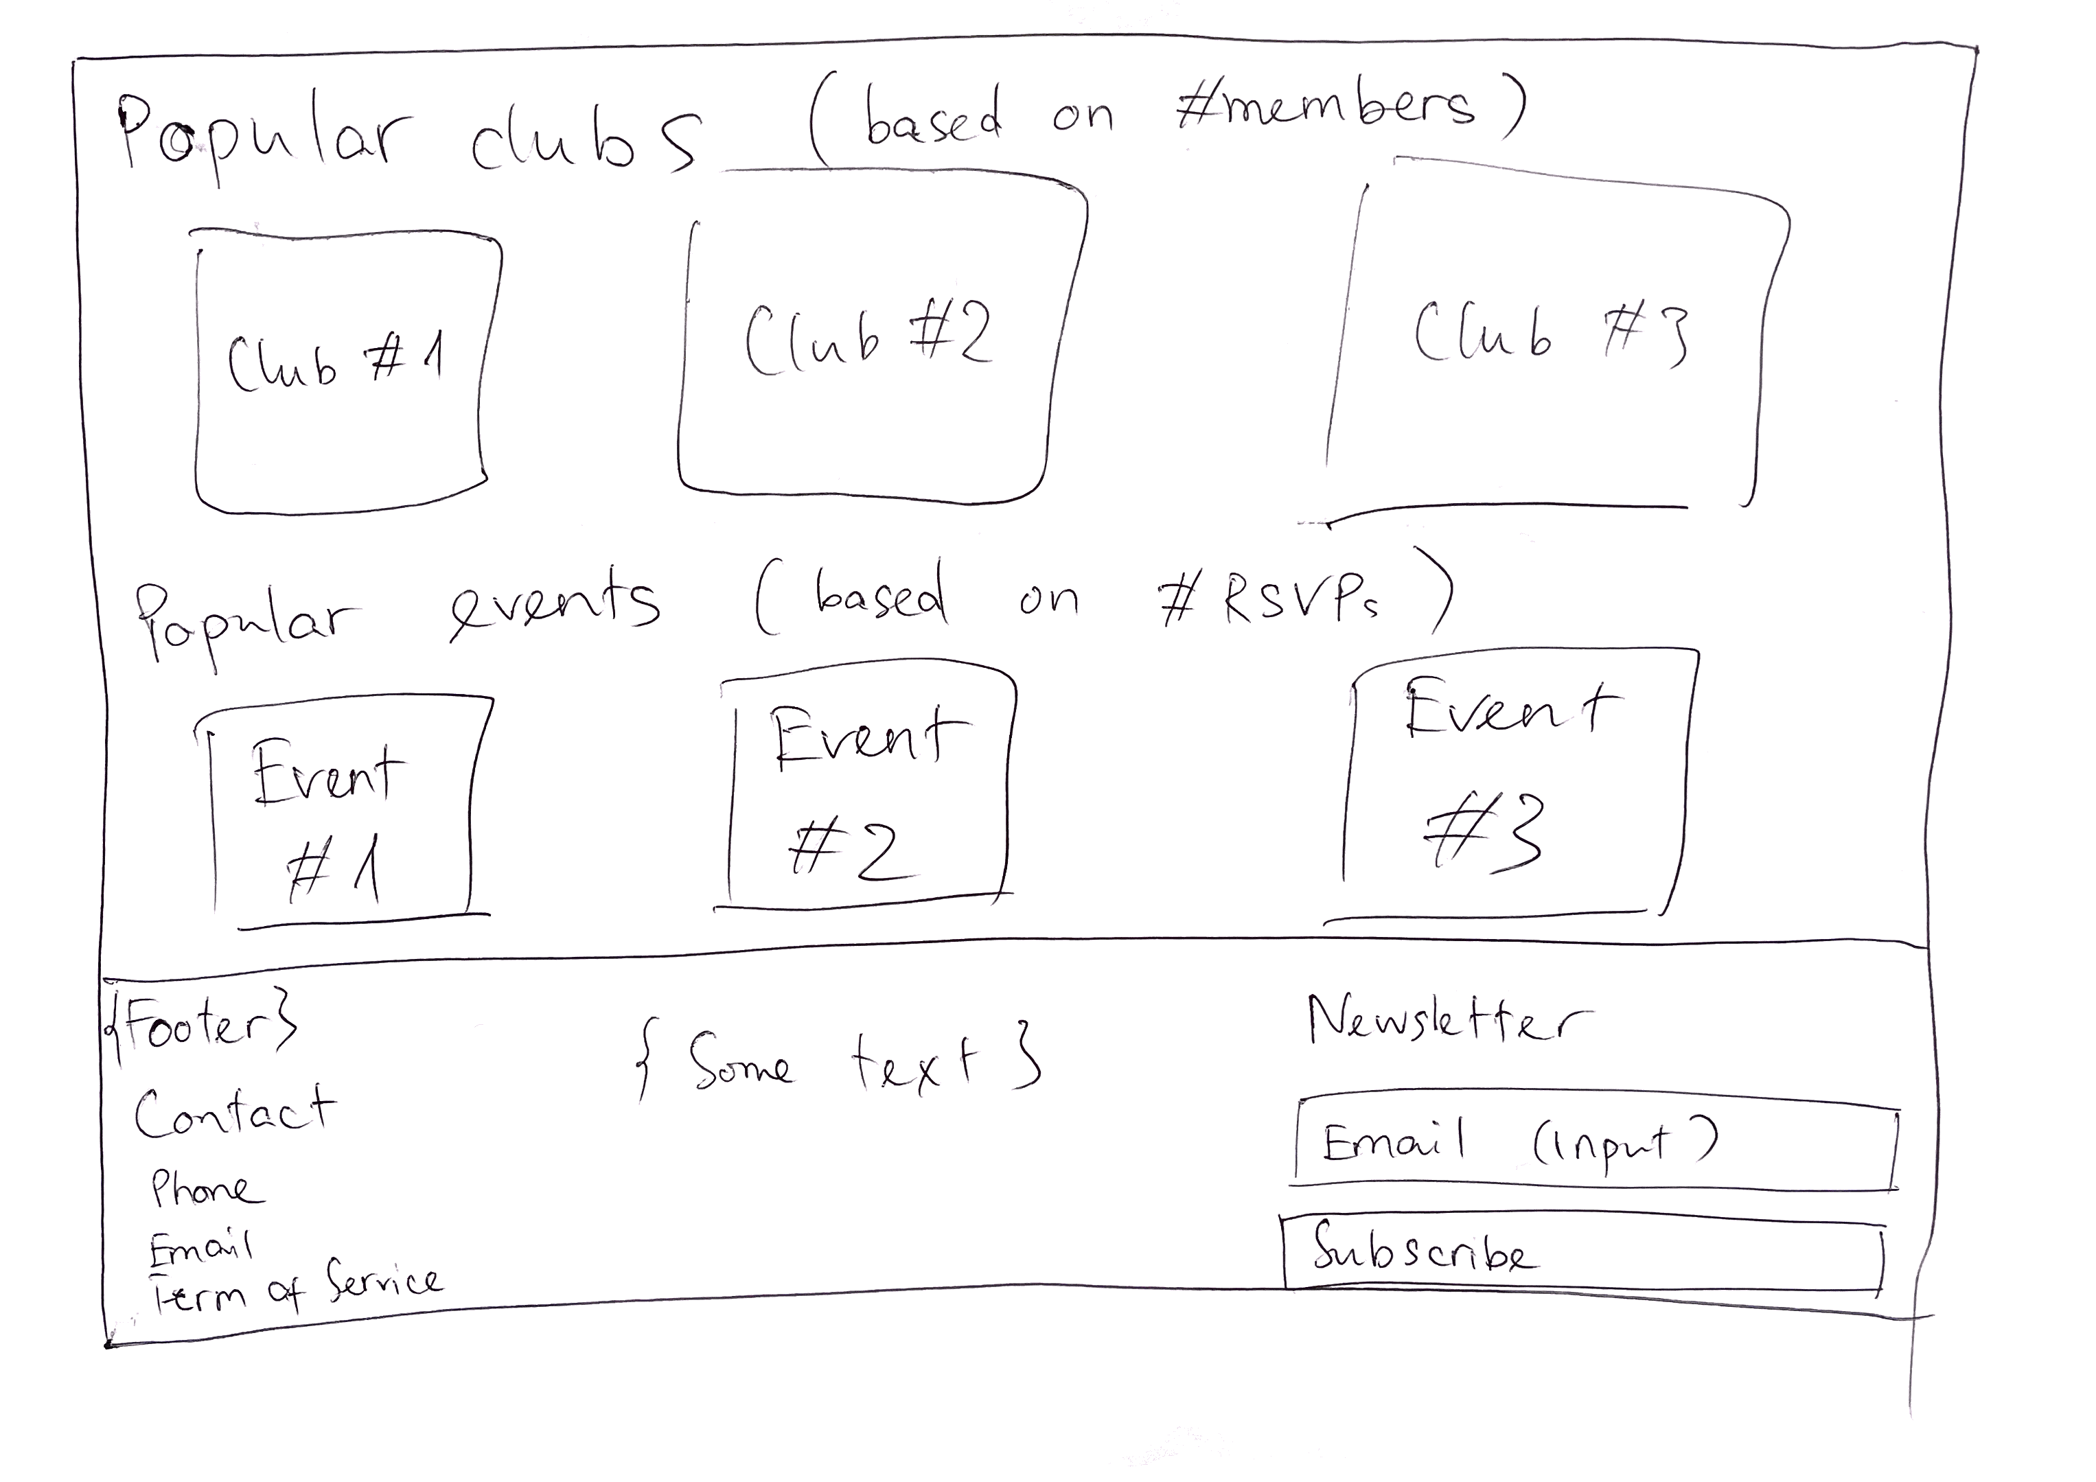

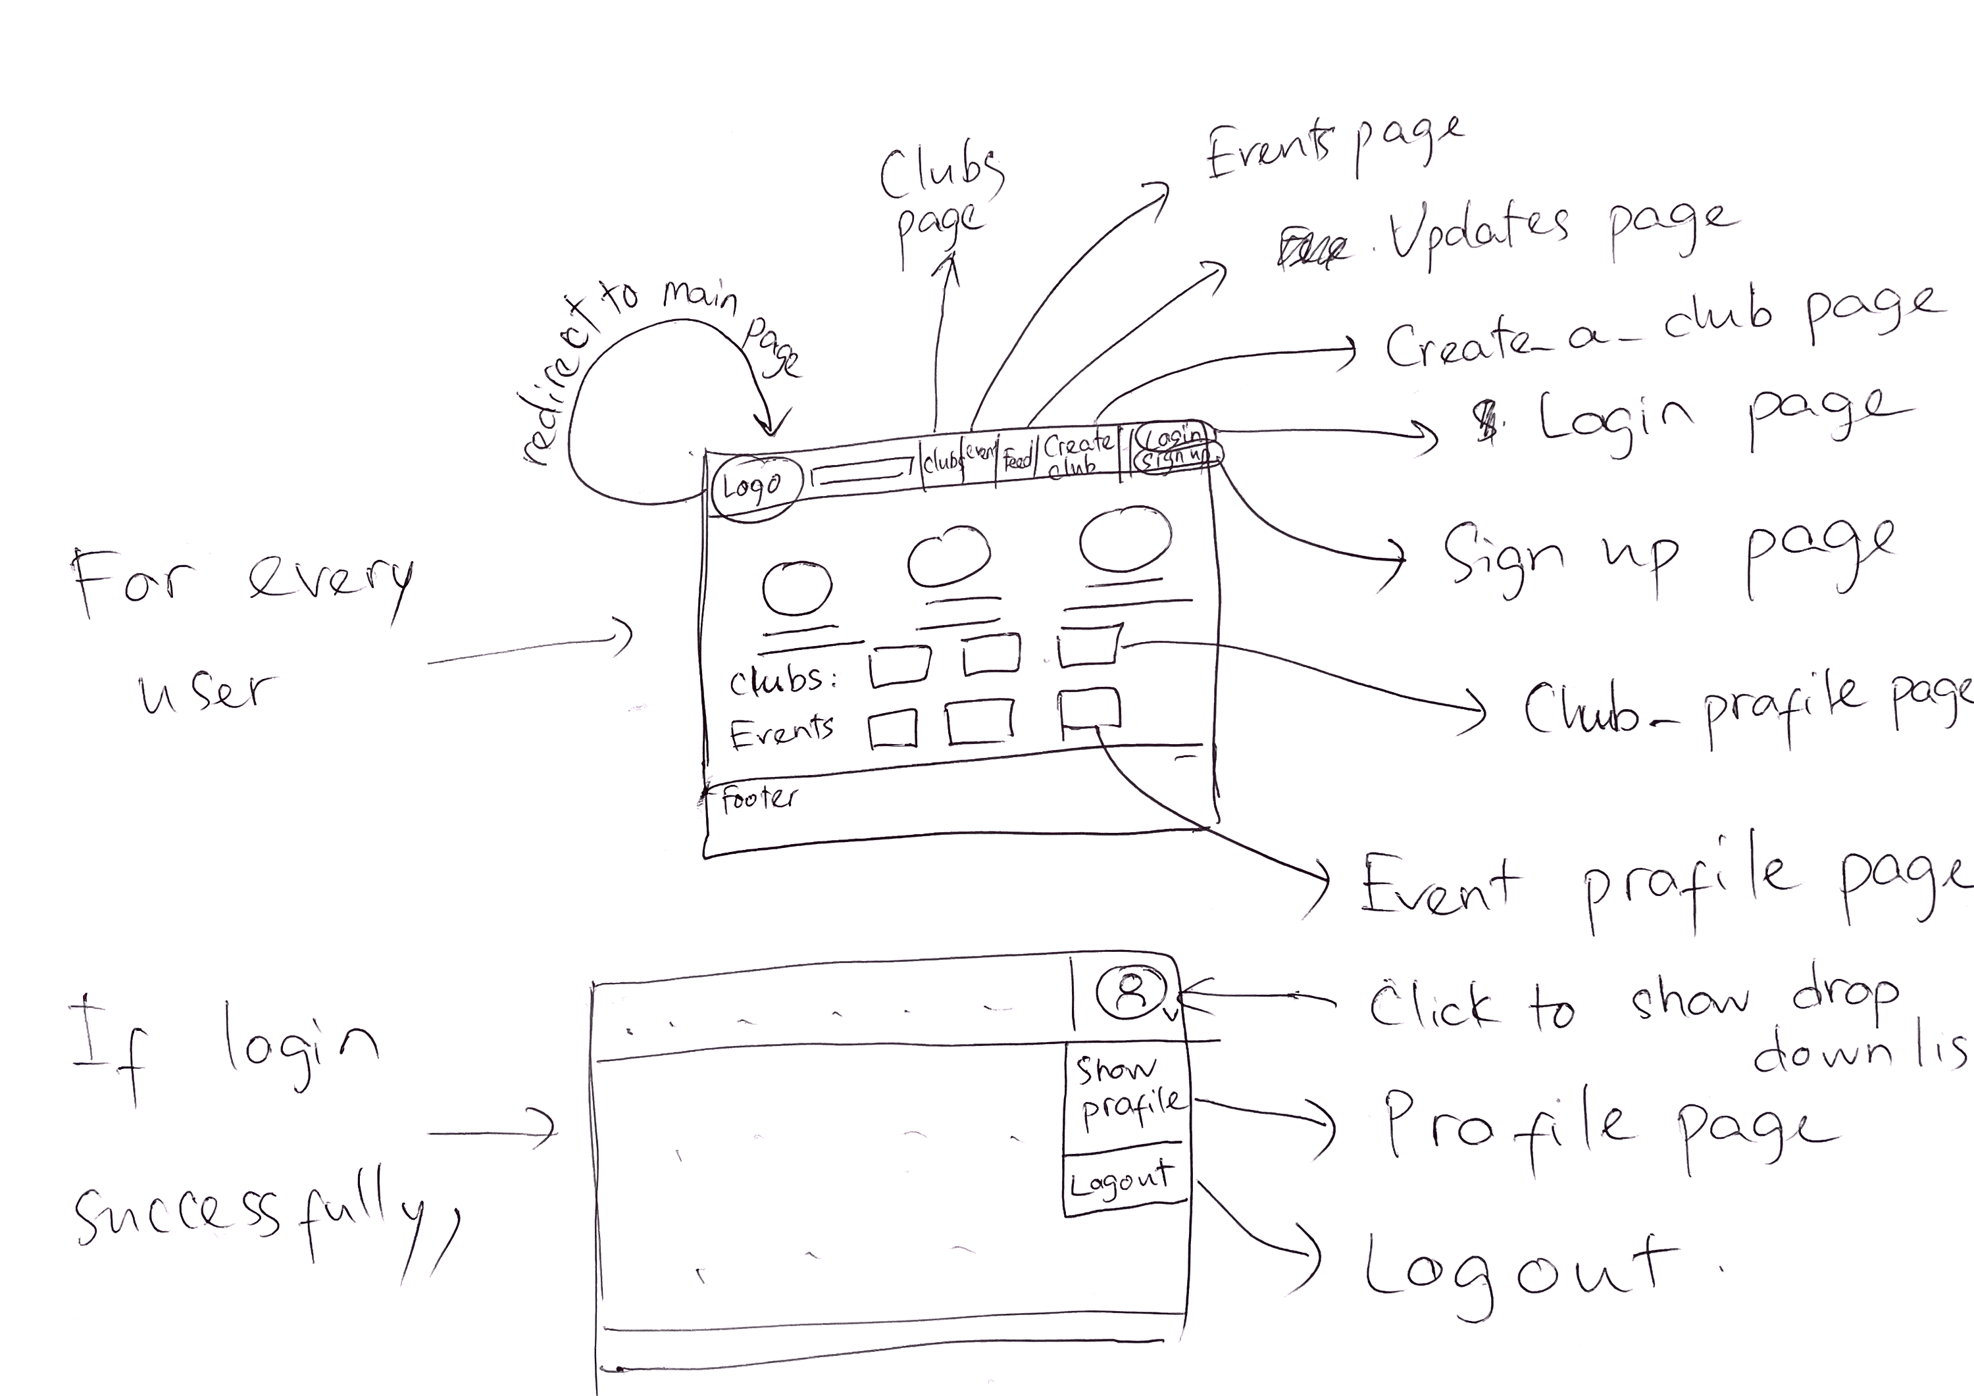

**Groups page:**

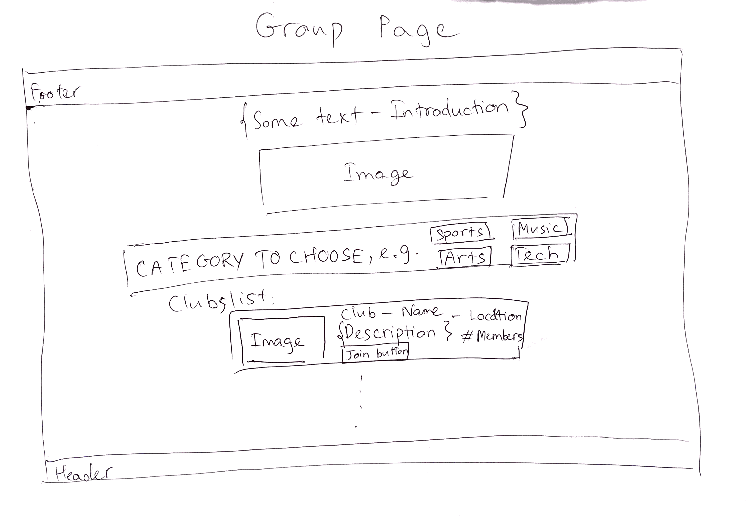

**Events page:**

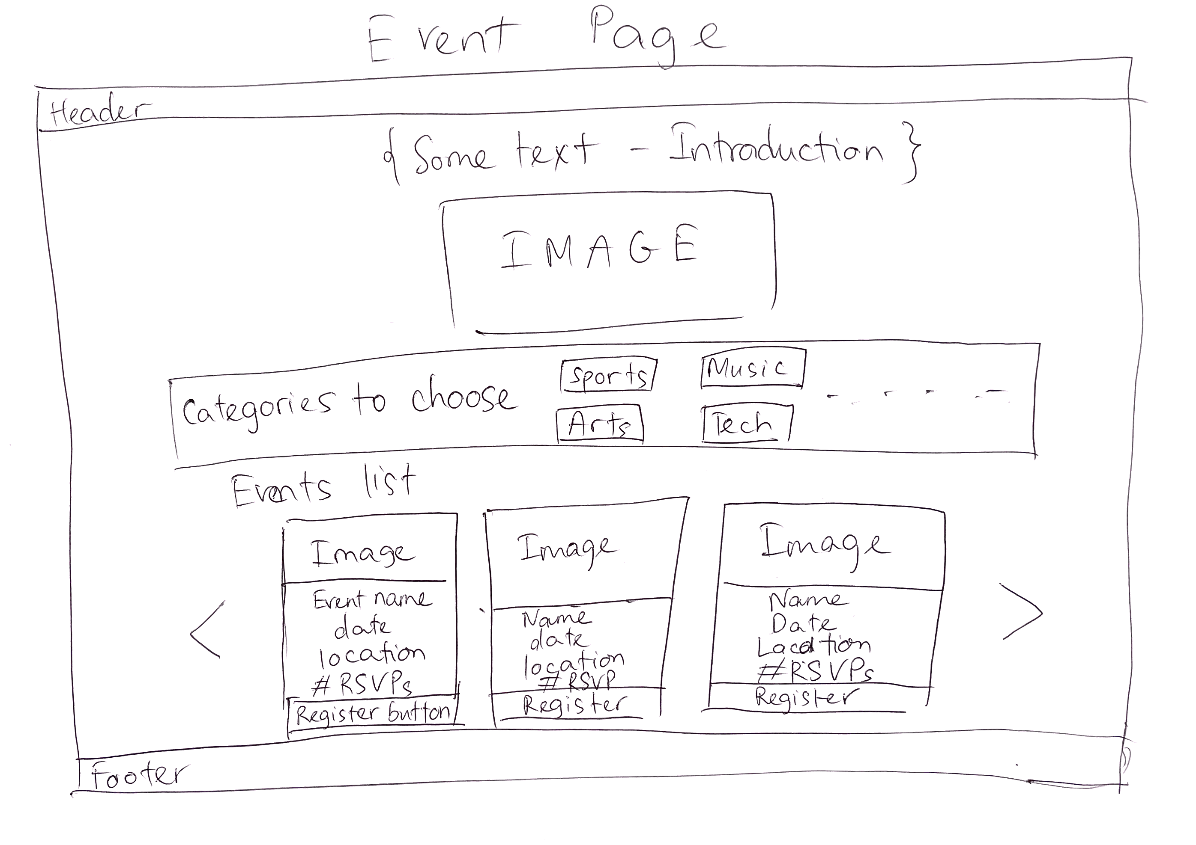

**Updates page:**

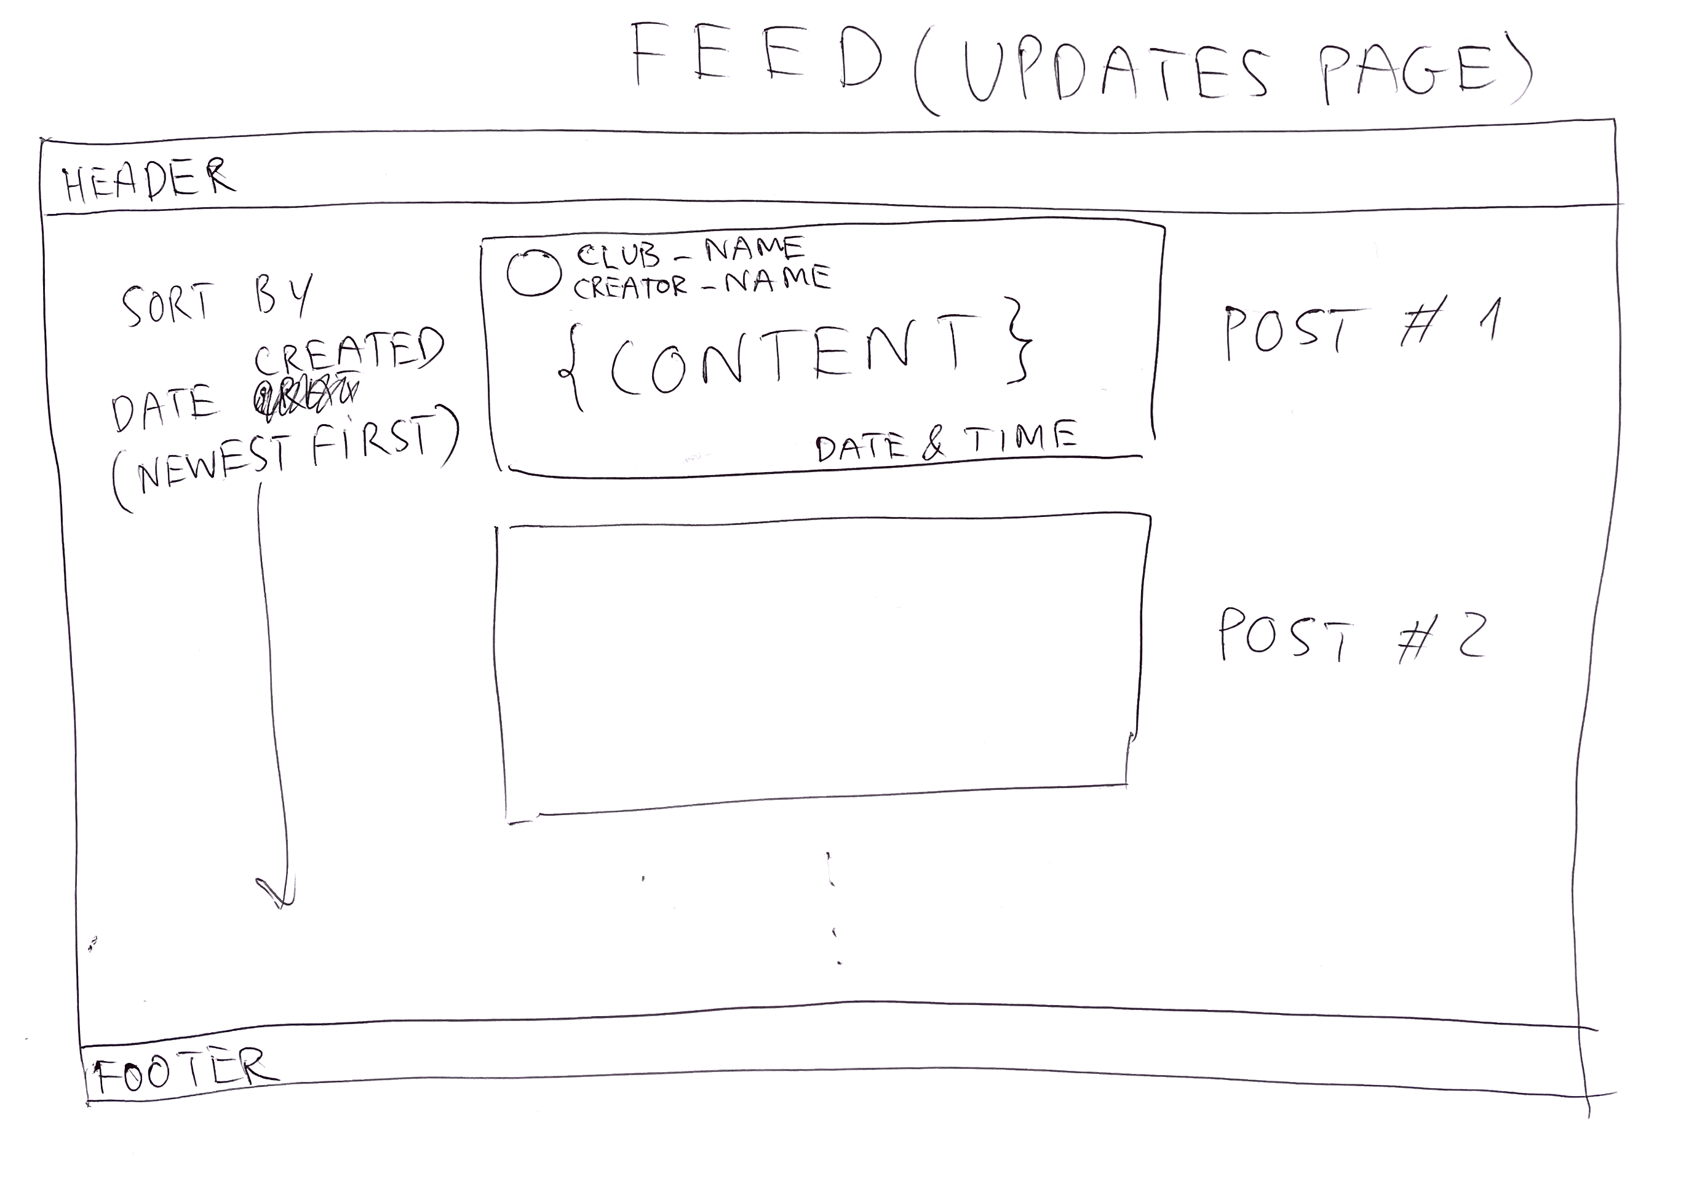

**Signup/Login page:**

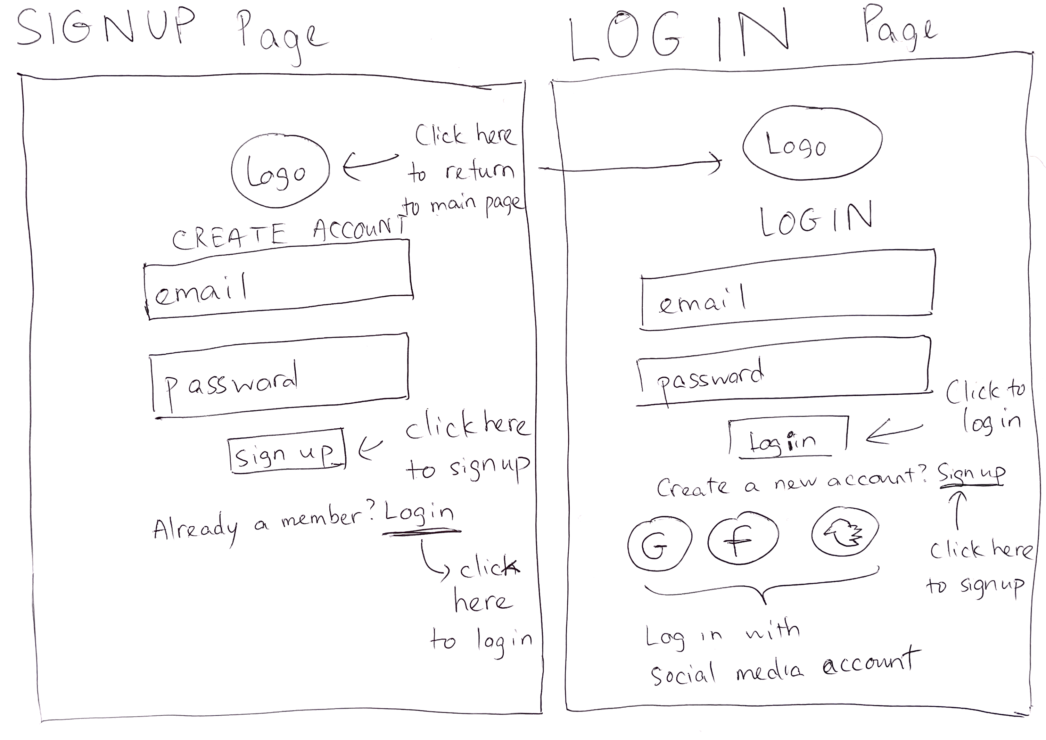

**User profile page:**

**IV. Features:**

**All users:**

Signup/Login:

Manage their user information:

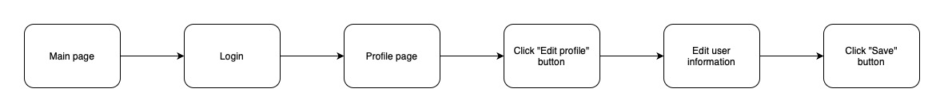

**Users:**

Join a club:

View updates from clubs they’re members of:

See upcoming club events and RSVP:

**Club managers:**

View their members:

Post updates both publicly, and privately to their members:

Create and update club events:

See who has RSVP’d for an event:

**System admins:**

Manage users:

Manage clubs:

Sign-up other Admins:

**V. Review:**

During the design phase, our primary focus was on minimizing both kinematic and cognitive load for users in our social web application. We implemented a range of strategies and techniques to ensure a smooth and intuitive user experience, reducing the physical and mental effort required to interact with the system.

To address kinematic load, we placed a strong emphasis on simplifying user interactions and streamlining navigation. For common actions like signing up, logging in, and creating clubs or events, we carefully designed the interface to minimize the number of steps and input fields involved. By presenting clear and concise forms, users can complete these tasks quickly and efficiently. Joining a club or registering for an event has been made effortless with a single "Join" button, eliminating the need for users to navigate through multiple pages or fill out lengthy forms. This streamlined approach reduces the physical effort required to perform these actions and allows users to engage with their desired activities seamlessly.

In addition to simplifying interactions, we optimized the layout and positioning of key interface elements to further reduce kinematic load. Important actions such as viewing club updates and upcoming events are prominently placed and easily accessible. By following consistent design patterns, such as placing the navigation menu in a familiar location and using recognizable icons, users can quickly find the information they need without unnecessary searching or exploration.

Turning to cognitive load, we focused on providing clear and intuitive navigation throughout the application. We organized the application's structure in a logical and hierarchical manner, allowing users to easily navigate between sections and functionalities. A straightforward menu structure grants users’ direct access to important features such as managing user information, joining clubs, viewing updates, and RSVPing for events, requiring minimal cognitive effort. By reducing the need for extensive searching or guesswork, we create a seamless and effortless user experience.

Furthermore, we aimed to present information in a concise and easily digestible format, avoiding information overload. When displaying club listings or event descriptions, we emphasized key details such as club names, event titles, dates, and brief summaries. This approach allows users to quickly scan and evaluate their interests without feeling overwhelmed by excessive content. By streamlining the information presented, we facilitate effective decision-making and alleviate cognitive burden.

Consistency and intuitiveness were key principles in our design language. By utilizing familiar UI components, standard iconography, and consistent terminology, we minimized the cognitive effort required for users to understand and navigate the platform. We aimed to align the system's representation with users' mental models, ensuring that they can effortlessly comprehend the application's features and functionality.

Error prevention was another area of focus to reduce cognitive load. We implemented validation mechanisms and provided clear error messages to help users identify and correct input errors during the sign-up or login process. By offering contextual and actionable feedback, we enable users to rectify mistakes easily and proceed smoothly without frustration or confusion.

Overall, our design approach centred on simplicity, clarity, and consistency to minimize both kinematic and cognitive load. Through techniques such as progressive disclosure, optimized layout, clear feedback, and error prevention, we aimed to create an intuitive and user-friendly social web application that effectively reduces the cognitive and kinematic effort required from our users.